**COURIER MITRA**

***A Mini Project-I Report submitted***

***in partial fulfilment of the requirements***

***for the award of the degree of***

**BACHELOROFTECHNOLOGY**

***In***

**COMPUTER SCIENCE & ENGINEERING**

***By***

1. PALAKURTHI DEDEEPYA-19B01A05D0 4. TUTTAGUNTA SAI ROSHINI-19B01A05H6

2. PUPPALA VENKATA LAHARI-19B01A05F6 5. THOPULA SAI VINEELA-20B05A0518

3. TADI SAI SRI MAHALAKSHMI-19B01A05G5

***Under the esteemed guidance of***

***Dr. V V R Maheshwara Rao***



**DEPARTMENT OF COMPUTER SCIENCE & ENGINEERING**

**SHRI VISHNU ENGINEERING COLLEGE FOR WOMEN(A)**

**(Approved by AICTE, Accredited by NBA & NAAC, Affiliated to JNTU Kakinada)**

**BHIMAVARAM – 534 202**

**2020 – 2021**

**SHRI VISHNU ENGINEERING COLLEGE FOR WOMEN (A)**

**(Approved by AICTE, Accredited by NBA & NAAC, Affiliated to JNTU Kakinada)**

**BHIMAVARAM – 534 202**

**DEPARTMENT OF COMPUTER SCIENCE & ENGINEERING**



**CERTIFICATE**

*This is to certify that the Mini Project-I entitled “****CourierMitra****”, is being submitted by* ***Tuttagunta Sai Roshini*** *bearing the* ***Regd. No. 19B01A05H6*** *in partial fulfillment of the requirements for the award of the degree of “****Bachelor of Technology*** *in* ***Computer Science & Engineering****” is a record of bonafide work carried out by her under my guidance and supervision during the academic year* **2020 – 2021** *and it has been found worthy of acceptance according to the requirements of the university.*

Internal Guide Head of the Department

**ACKNOWLEDGEMENT**

The satisfaction that accompanies the successful completion of any task would be incomplete without the mention of the people who made it possible and whose constant encouragement and guidance has been a source of inspiration throughout this project. We take this opportunity to express our gratitude to all those who helped us in this project.

We would like to express our special thanks of gratitude to Sri. **K.V. Vishnu Raju** ,

Chairman of SVES, for creating academic ambience and excellent infrastructure facilities.

We would also like to extend our gratitude to the  **Dr. G. Srinivasa Rao,** Principal of SVECW and **Dr. P. Srinivasa Raju**, Vice-Principal of SVECW for being a source of an inspirational constant encouragement.

We deeply indebted and sincere thanks to **Dr. P. Kiran Sree**, Head of the Department, for his valuable advice in completing this project successfully.

We would like to extend our gratitude and sincere thanks to **Dr. V.V.R. Maheswara Rao** for his encouragement and support, valuable suggestion throughout my project.

1. Palakurthi Dedeepya - 19B01A05D0
2. Tuttagunta Sai Roshini - 19B01A05H6
3. Puppala Venkata Lahari - 19B01A05F6
4. Tadi Sai Sri MahaLakshmi - 19B01A05G5
5. Thopula Sai Vineela - 20B05A0518

**ABSTRACT**

CourierMitra is a web based application helpful for the students. Our website is designed such a Way to provide entire details of their couriers in website. Firstly, the student should provide the entire details of their couriers in CourierMitra Website.

The details of the couriers are maintained by admin, and check status of courier and updates to user through provided mail.

The existing system is an manual one in which user maintaining ledgers, books etc. to store the information like good details, loading. Particulars, deliveries particulars, details of receive of items at all branches, and customer details as well as employee details. It is very difficult to main historical data also regular investments need to purchase stationery year.

The new system titled as “**Courier Mitra”** is hence Proposed to remove all the problems in existing system discuss above.

Proposed system is a software application which avoids more manual hour’s that need to spend record keeping and generating reports. This application keeps the data in a centralized way is available to all the user simultaneously. It is very easy to manage historical data in database. No specific training is required for the employee to use this application.

They can easily use the tool that decrease manual hour’s spending for normal things and hence increase the performance as the data is centralized it is very easy to maintain the status of the courier details.

Contents

**S. No.** **Topic**  **Page No.**

1. Introduction 01 - 02
2. System Analysis 03 - 07

2.1 Existing System

2.2 Proposed System

2.3 Feasibility Study

1. System Requirements Specification 08 - 09

3.1 Software Requirements

3.2 Hardware Requirements

3.3 Functional Requirements

1. System Design 10 - 20

4.1 Introduction

4.2 System Architecture

4.3 UML Diagrams

1. System Implementation 21 - 32

5.1 Introduction

5.2 Project Modules

5.3 Screens

1. System Testing 33 - 44

6.1 Introduction

6.2 Testing Methods

6.3 Test Cases

7. Conclusion & Future Enhancements 45

8. Bibliography 46

9. Appendix 47

**INTRODUCTION**

**Introduction**

At present scenario everything around us were made easy to receive without going out by ourselves for purchasing the things. Also if we need to send any parcel or credentials to other persons it is done without our presence in that place.

This is all because of Courier services and online shopping websites. It is also important to receive the things that we place the order or the credentials that were send to us.

The project motive is to make things easier for the college students preferably hostelers to handle with the couriers that they receive.

In most of the cases while delivering the courier if the person unable to attend the courier boy call then the courier may send back to the courier centers this may lead to loss of couriers and even their valuable time for students.

At the same time the student may not be able to always go to courier office to check whether the courier is received or not after the arrival date by the courier office so in order to avoid such kind of issues this project is evolved.

**SYSTEM ANALYSIS**

**2. System Analysis:**

It is a process of collecting and interpreting facts, identifying the problems, and decomposition of a system into its components.

System analysis is conducted for the purpose of studying a system or its parts in order to identify its objectives. It is a problem solving technique that improves the system and ensures that all the components of the system work efficiently to accomplish their purpose.

**2.1 Existing System:**

The existing system is an manual one in which user maintaining ledgers, books etc. to store the information like good details, loading. Particulars, deliveries particulars, details of receive of items at all branches, and customer details as well as employee details. It is very difficult to main historical data also regular investments need to purchase stationery year.

**Disadvantages of Existing System:**

1. It is difficult to maintain important information in books.
2. More manual hour’s need to generate required reports.
3. It is tedious to manage historical data which need which space to keep all the previous year’s ledgers, books, etc...
4. Daily transaction are to be entering into different books immediately to avoid conflicts which are very difficult.
5. No coordination between different branches because we are not storing the data at centralized location.

**2.2** **PROPOSED SYSTEM:**

The new system titled as “**CourierMitra”** is hence Proposed to remove all the problems in existing system discuss above

Proposed system is a software application which avoids more manual hour’s that need to spend record keeping and generating reports. This application keeps the data in a centralized way is available to the entire user simultaneously. It is very easy to manage historical data in database. No specific training is required for the employee to use this application. They can easily use the tool that decrease manual hour’s spending for normal things and hence increase the performance as the data is centralized it is very easy to maintain the status of the courier details.

**Advantages of Proposed System:**

1. Easy to manage all the daily transaction.
2. Centralized database help’s in avoiding conflicts between branches.
3. Avoids human errors.
4. Provides better customer support from any branch.
5. Can generate required reports easily.
6. Easy to manage historical data in a secure manner
7. Easy to use GUI that doesn’t requires specific training.

**2.3 FEASIBILITYSTUDY**

An feasibility study is test of system proposal according to it's work ability, impact on the organization, ability to meet user needs, And effective use of resources. The objective of the feasibility study is not to solve the problem but to acquire a sense of its scope. Every software project begins with a judgment as to whether the project is valuable or not. A feasibility study is an evaluation and analysis of the potential of the proposed project which is based on extensive investigation bad research to support the process of decision of decision making. Feasibility studies aim to objectively and rationally uncover the strengths and weaknesses of an existing business or proposed venture, opportunities and threats present in the environment, the resource required to carry through, and ultimately the prospects for success, in it’s simplest terms , the two criteria to judge feasibility are cost required and value to be attained. An well designed feasibility study should be provide a historical background of business or project description of the product or service, accounting statements, details of the operations and management marketing research and

policies, financial data, legal requirements and tax obligations. Generally feasibility study precede technical development is called feasibility study.

A software feasibility study has three solid dimensions.

* Technical Feasibility.
* Operational Feasibility.
* Cost- Benefit Analysis.

**TECHNICAL FEASIBILITY:**

The project is technically feasible. It successfully satisfies the user’s basic requirements. The tools and applications software used in this project are Very popular and easy available across the world. A technical feasibility study accesses to details of how you intend to deliver a product or service to customers. Think materials, labour, transportation, where your business will be located and the technology that will be necessary to bring all this together. The main aspect to be considered under this study is technology of the project.

* Information about the technology and technical aspects.
* Production pattern.
* Process selection.
* Technology selected.
* All project updates.

**OPERATIONAL FEASIBILITY :**

The system will have easy to understand interface for different modules. It does not require any programming skills to use the system. After a little training, the user will able to work with it at easy.

**COST** - **BENEFITANALYSIS** (**ECONOMICFEASIBILITY**):

The organization expects a return on investment. Money provides the ready – made metric for measuring value. This kind of investigation is called investment appraisal or a cost – benefit analysis. This organization accepts a returns on investment is called a economic feasibility.

* In this approach two quantities are calculated. The cost of providing system.
* The money saved are created by using system.

If the benefits are greater than the he cost, the system is worthwhile; otherwise, it is not. If there is some other way of accomplishing the same task, which may be manually. Then it is necessary to compare the two costs. Whichever technique gives the smaller cost is the on to select, if the benefit is greater than the cost with each of the these criteria, we can associate a cost, through for some it is less easy.

* Cost to buy equipment, principally the hardware.
* Cost to develop the software.
* Cost of training.
* Cost of lost work during switch over.
* Cost to repair the equipment in the event of failure.
* Cost of loss work in the event of failure.
* Cost to upgrade, in the event of changed requirements.

**Importance of the Feasibility Study:**

The information you gather and present in your Feasibility Study will help you.

* List in detail all the things you need to make the business work.
* Identify logistical and other business related problems and solutions.
* Develop marketing strategies to convince a bank or investor that your business is worth considering as an investment.
* Service as a solid foundation for developing your business plans.
* It is help the management to make an informed ision on which path should be pursued in order to create the most profitable revenue stream for the construction company.

**SYSTEM REQUIREMENTS SPECIFICATION**

**System Requirements Specification**

**3.1** **Software Requirements**

* Visual Studio Code
* XAMPP
* Languages : HTML, CSS ,PHP, Angular JS

**3.2 Hardware Requirements**

* Processor : 1.9 GHz 64-Bit Dual Core Processor
* RAM : 2 GB
* Space on Hard Disk : 40 GB
* Display : Resolution of 1024×768

**3.3 Functional Requirements**

In Software Engineering, a functional requirement defines a function of a software system or its component. A function is described as a set of inputs, behaviour, outputs. Functional requirements may be calculations, technical details, data manipulation and supposed to accomplish. The plan for implementing functional requirements is detailed in the system design. In requirements engineering, functional requirement specify particular results of a system. Functional requirements drive the application architecture of a system.

The following are the functional requirements of our system.

* User need to give his/her courier details.
* Admin checks and update the status of users couriers.
* According to the status updated by admin user will get the mail that the courier received / delivered to user .

**SYSTEM DESIGN**

**System Design**

**4.1 Introduction**

Design is the first step in the development phase of an engineering product or system. Design is the place where quality is considered in the software development. Design is the only way that we can accurately translate user requirements into finished software product or system. Software design serves as the foundation for all the software engineers and software maintenance that steps follow. Without design we risk building an unstable design one that will fail when small changes are made, one that may be difficult to test and one whose quantity cannot be assessed until late in software engineering process.

**4.2 System Architecture**

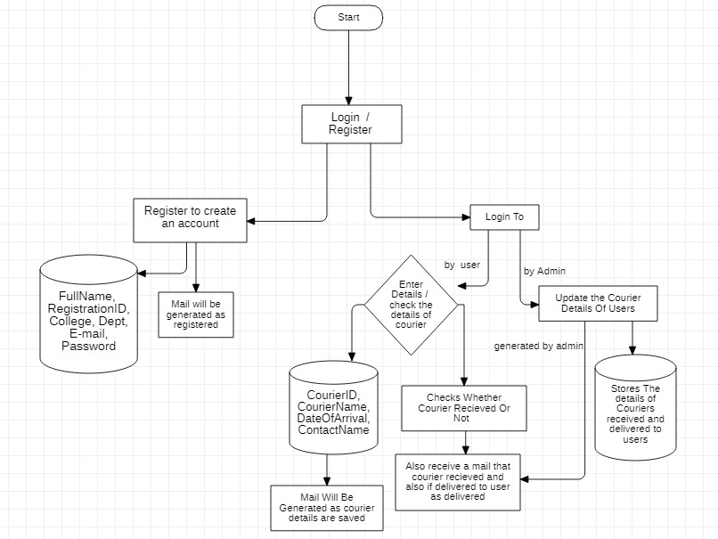

**4.3 UML Diagrams**

**Introduction to UML**

**Unified Modelling Language (UML)** is a general purpose modelling language. UML is a way of visualizing a software program using a collection of diagrams. It is blue print for designing software systems. UML plays an important role in defining different perspectives of a system. These perspectives are

* Design
* Implementation
* Process
* Deployment

UML is a standard language for specifying, visualizing, constructing, and documenting the artefacts of software systems. We use UML diagrams to portray the **behaviour and structure** of a system. Provide users with a ready-to-use, expressive visual modelling language so they can develop and exchange meaningful models.

These diagrams are organized into two distinct groups: **structural diagrams** and **behavioural** or interaction diagrams.

**Structural diagrams** depict a static view or structure of a system. It is widely used in the documentation of software architecture.

**Behavioural diagrams** portray a dynamic view of a system or the behaviour of a system, which describes the functioning of the system.

There are various diagrams for designing a software

* Use case diagrams
* Class diagrams
* Activity diagrams
* Sequence diagrams
* State chart diagram

**4.3.1 Use Case Diagram**

A use case diagram is a dynamic or behaviour diagram in [UML](https://www.smartdraw.com/uml-diagram/). Use case diagrams model the functionality of a system using actors and use cases. Use cases are a set of actions, services, and functions that the system needs to perform. Use case diagrams are valuable for visualizing the functional requirements of a system that will translate into design choices and development priorities.

Basic symbols are used in use case diagrams.

**System**

System's boundaries using a **rectangle** that contains use cases. Place actors outside the system's boundaries.

**Use Case**

Use cases are represented using an oval. Describes how actors use the system to accomplish a particular goal.

**Actors**

**Actors are represented using actor symbol. Actors are of two types primary and secondary actors.**

**Primary actors: Initializes the use of the system. Placed left of the system**

**Secondary actors : These will be the reactionary for the primary actor action. Placed right to the system.**

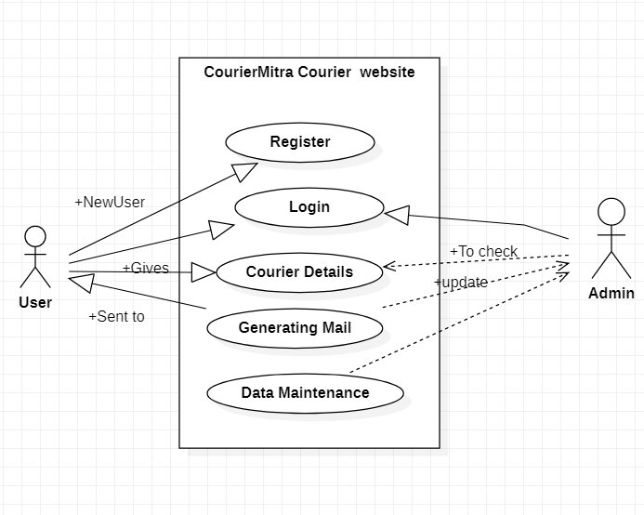

4.3.1 Use Case diagram

**4.3.2 Class Diagrams**

The class diagram depicts a static view of an application. It represents the types of objects residing in the system and the relationships between them. A class consists of its objects, and also it may inherit from other classes. A class diagram is used to visualize, describe, and document various different aspects of the system.

It shows the attributes, classes, functions, and relationships to give an overview of the software system. It **constitutes class names, attributes, and operations in a separate compartment** that helps in software development

Basic symbols used in class diagrams

**Classes:**

Classes represent an abstraction of entities with common characteristics.

**Active Classes:**

Active classes initiate and control the flow of activity, while passive classes store data and serve other classes. Illustrate active classes with a thicker border.

**Visibility:**

Use visibility markers to signify who can access the information contained within a class.

**+ public operation**

**- private operation**

**# protected operation**

**Associations:**

Associations represent static relationships between classes. Use a filled arrow to indicate the direction of the relationship. Place roles near the end of an association. Roles represent the way the two classes see each other.

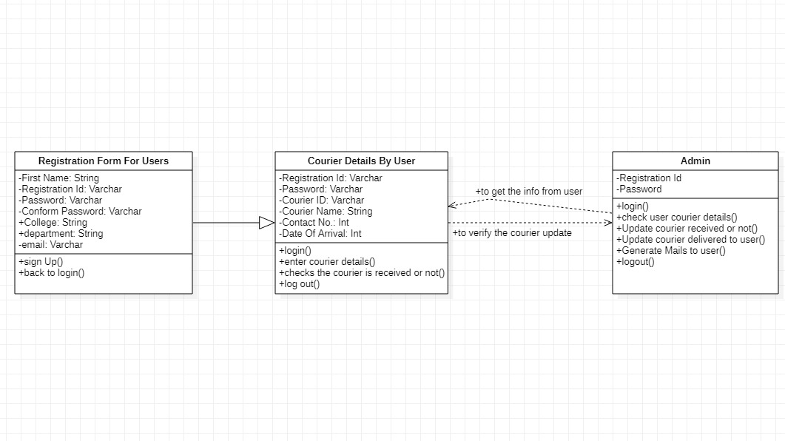

Figure 4.3.2 Class Diagram

**4.3.3 Sequence Diagram**

A sequence diagram simply depicts interaction between objects in a sequential order i.e, the order in which interactions take place. We can also use the terms event diagrams or event scenarios to refer to a sequence diagram. Sequence diagrams describe how and in what order the objects in a system function. Sequence diagrams are used to formalize the behaviour of the system and to visualize the communication among objects. These are useful for identifying additional objects that participate in the use cases. These diagrams are widely used by businessmen and software developers to document and understand requirements for new and existing systems.

**4.3.4 Activity Diagram**

Activity diagram is basically a flowchart to represent the flow from one activity to another activity. The activity can be described as an operation of the system. The control flow is drawn from one operation to another. This flow can be sequential, branched or concurrent. The basic purposes of activity diagram is similar to other four diagrams. It captures the dynamic behaviour of the system. Other four diagrams are used to show the message flow from one object diagram to another.

Activity is a particular operation of the system. Activity diagrams are not only used for visualizing the dynamic nature of the system but they are also used to construct the executable system by using forward and reverse engineering techniques. Activity diagrams are something considered as flowchart. It shows different flows such as parallel, branched, concurrent, and single

* Describe the sequence from one activity to another.

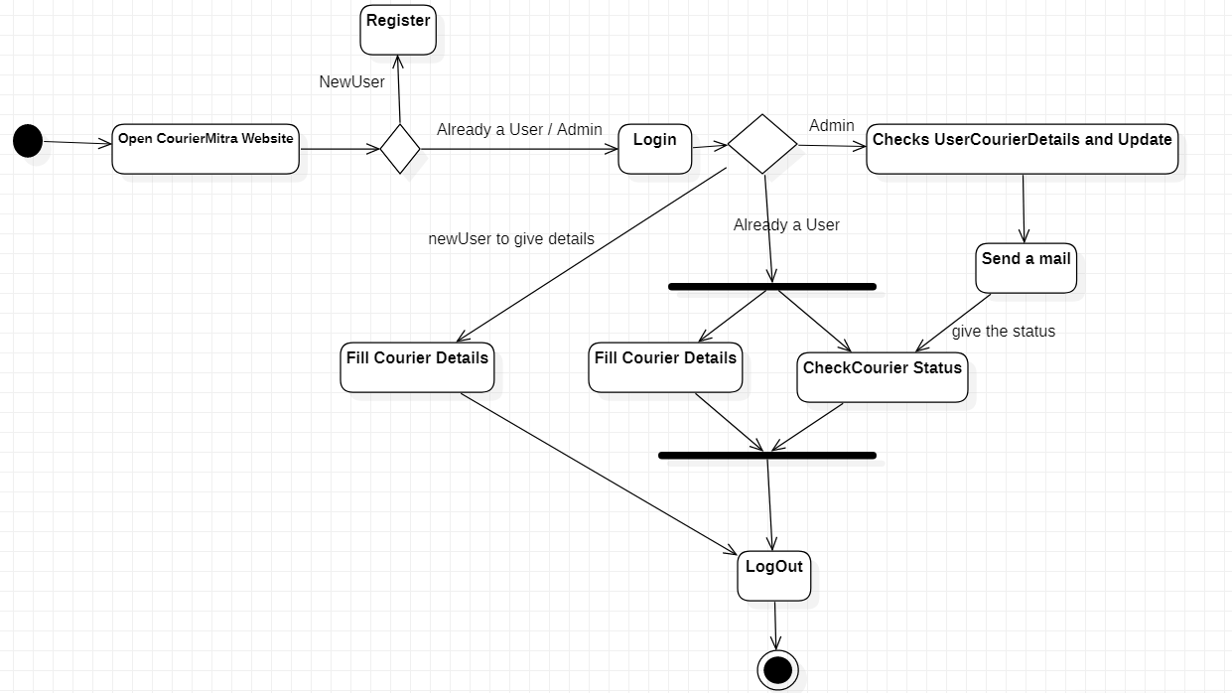

4.3.4 Activity Diagram

**4.3.5 State Chart Diagram**

State chart diagram describes the flow of control from one state to another state. States are defined as a condition in which an object exists and it changes when some event is triggered. The most important purpose of State chart diagram is to model lifetime of an object from creation to termination. State chart diagrams are also used for forward and reverse engineering of a system. However, the main purpose is to model the reactive system.

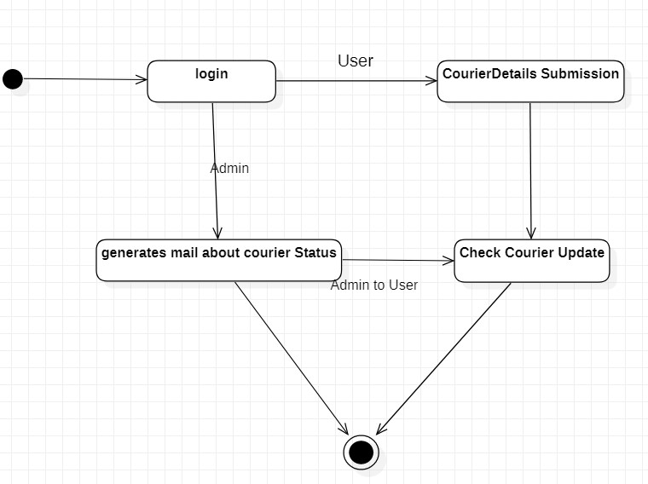

4.3.5 State chart diagram

**SYSTEM IMPLEMENTATION**

**5.1 Introduction:**

The purpose of system implementation can be summarized as follows: making the new system available to the prepared set of users(the deployment) and positioning on-going support and maintenance of the system within the Performing Organization(the transition).At a finer level of details deploying the system consists of executing all steps necessary to educate the Consumers on the use of the system ,placing the newly developed system into production, confirming that business functions that interact with the system and functioning properly. Transitioning the system support responsibilities involves changing from a system support and maintenance mode of operation, with ownership the new system moving from the project team to the performing organization.

A key difference between system implementation and all other phases of the life cycle is that all project activities up to this point have been performed in safe, protected and secure environments, where project issues that arise have little or no impact on day-to-day operations. It is through the careful planning, execution and management of system implementation activities that the project team can minimize the livelihood of these occurrences and determine appropriate contingency plans in the event of the problem.

Our project explores to make things easier for the college students preferably hostellers to handle with the couriers that they receive or not. Most of the cases while delivering the courier if the person unable to attend courier boy call then the courier may send back to courier centers this may leads to lots of problems for students. And at the same time the student may not be able to always go to office and to check whether the courier is received or not after the arrival date by courier office to avoid these types of issues this project is helpful. To deal with the issues faced by the students regarding couriers and couriers without any loss of package by the students as well as student hours. The web application will help students and it provides easy communication between user and receiver.

**5.2 Project Modules:**

1. User Module
2. Admin Module

**USER MODULE**

New User:

If he is a new user, he needs to register into the site.

Existing User:

If he is already an existing user, then they will give courier details.

ADMIN MODULE

* Check the user courier details.
* View the list of students.
* If the courier is received then admin will tick in received Check Box.
* And admin will verify whether the courier is arrived or not.
* Update status of courier details to the user.
* He will maintain database.

**USER MODULE :**

In our website COURIERMITRA there are two options

1. Registration Page

2. Login Page

If the user is new to website COURIERMITRA then we need to register him to the CourierMitra website. Using the Register button then the user should provide some details to the website like his full name, last name, registration number, email id, password, mobile number like that he/she should register to CourierMitra website. And then after the registration page in CourierMitra then we need to login to the website. After that Login page she/he should submits the details of delivery which includes date of arrival: on or before, product details etc. And then he/she should logout from the

site. When the courier date is coming then the person will log in from the site and he/she should frequently check whether the courier date is arrived or not. If the courier is received then he would go to courier office and he would take his courier. These procedure will be followed in the new user.

If the person is existing user then he/she would login from the site. The person will not register because he/she is already registered to the CourierMitra website. So the person will need not to register only he would login to the website. Then She/he submits the courier details which need to include date of arrival: on or before, product details etc. When the courier date is coming then the person will log in from the site and he/she should frequently check whether the courier date is arrived or not. If the courier is received then he would go to courier office and he would take his courier. This procedure will be followed in the existing user.

After giving the courier details to the website these details will be stored in database. So that the person can receive the product in time the student via this website to collect the product from him. This saves lot of time and there wouldn’t be any disturbances to the student during college hours. This requires database of students.

**ADMIN MODULE:**

First the admin will login to the site. And admin will give details like name and password. And admin will view list of students or check list of users ().Then the admin will verify details of users, courier details. Only admin will open this website and check user details. All user details will be gathered by one page to see list of students. If the courier is delivered to user/received to user the admin will send mail to user. And admin will update database of users. The details of couriers are maintained by admin and checks status of courier and updates to user through mail. Then admin will logout from the site.

**5.3 SCREENS**

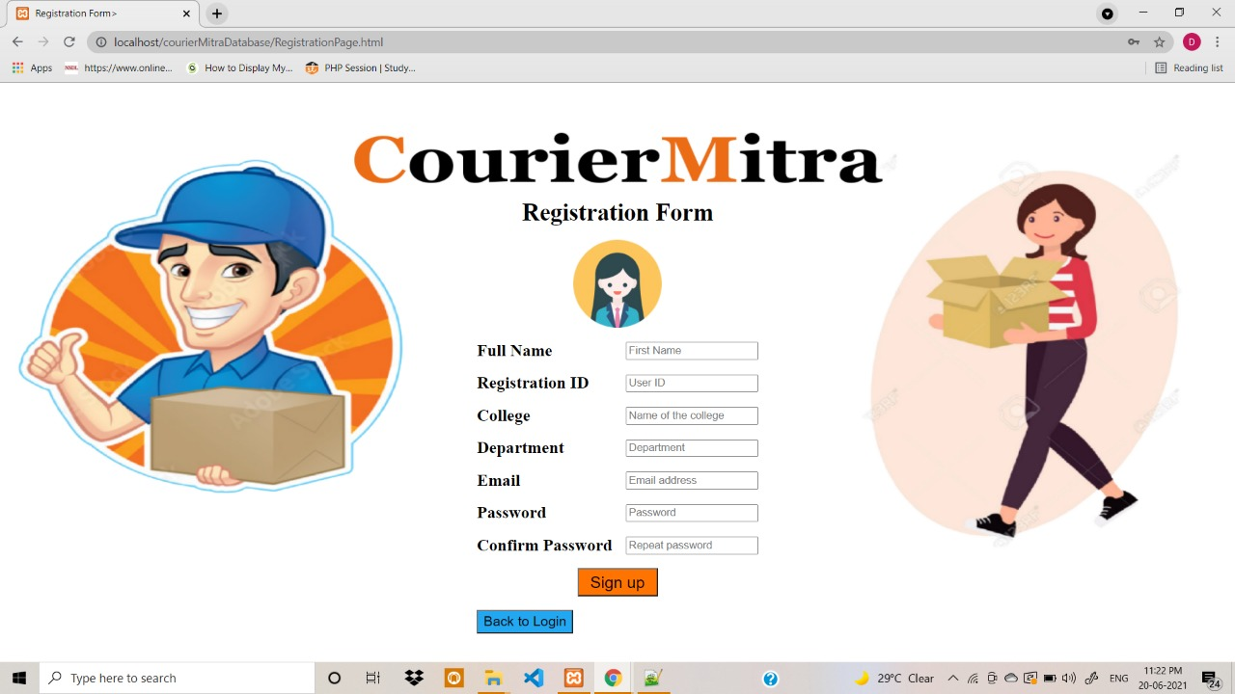**REGISTER:**

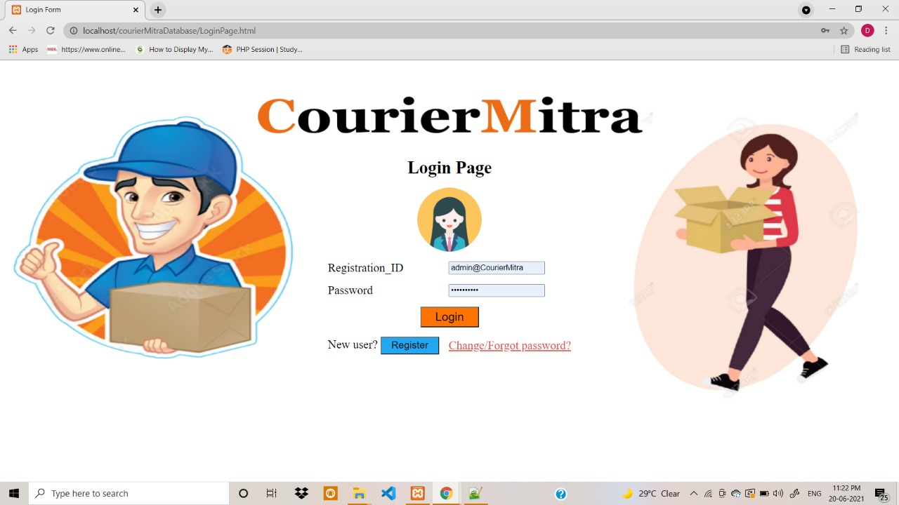**LOGIN:**

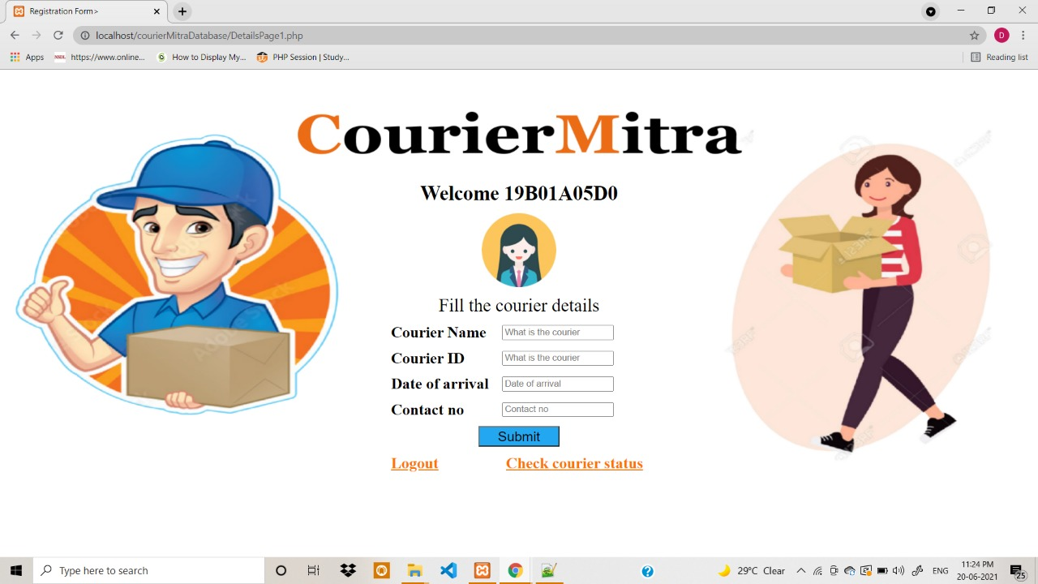**COURIER DETAILS**

**CHANGE PASSWORD:**

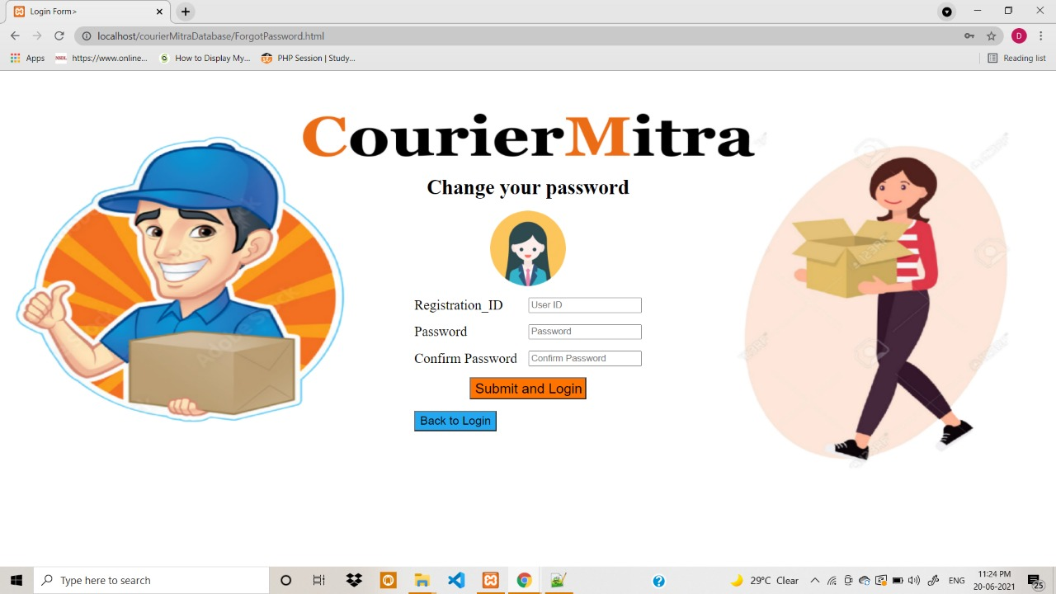

**ADMIN PAGE :**

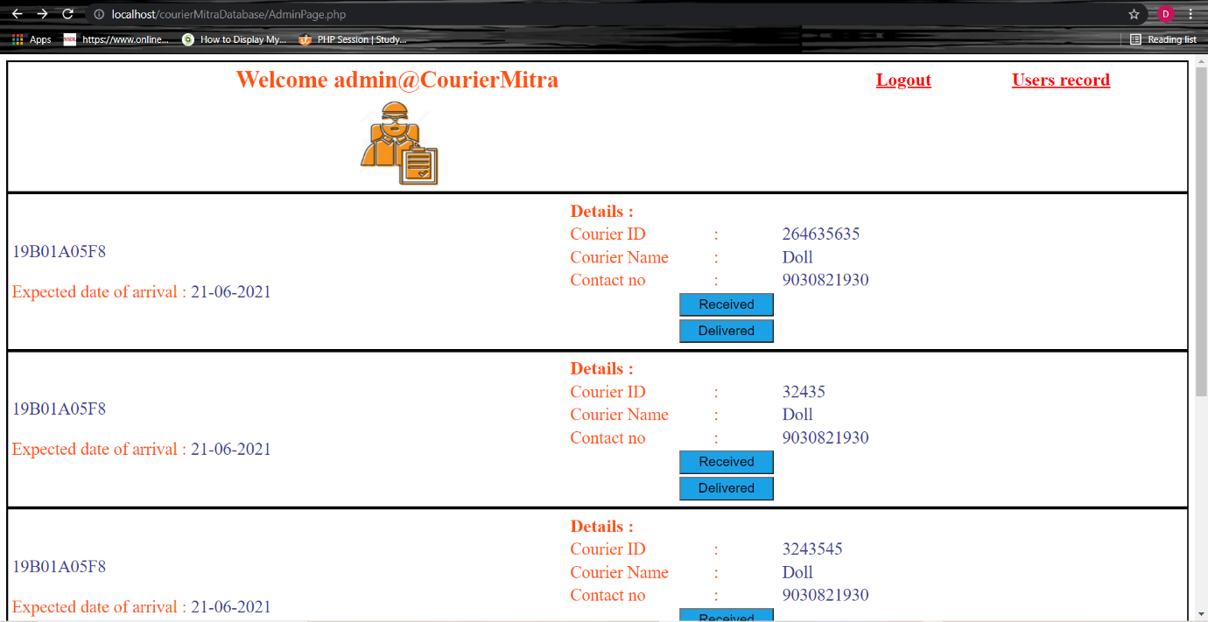

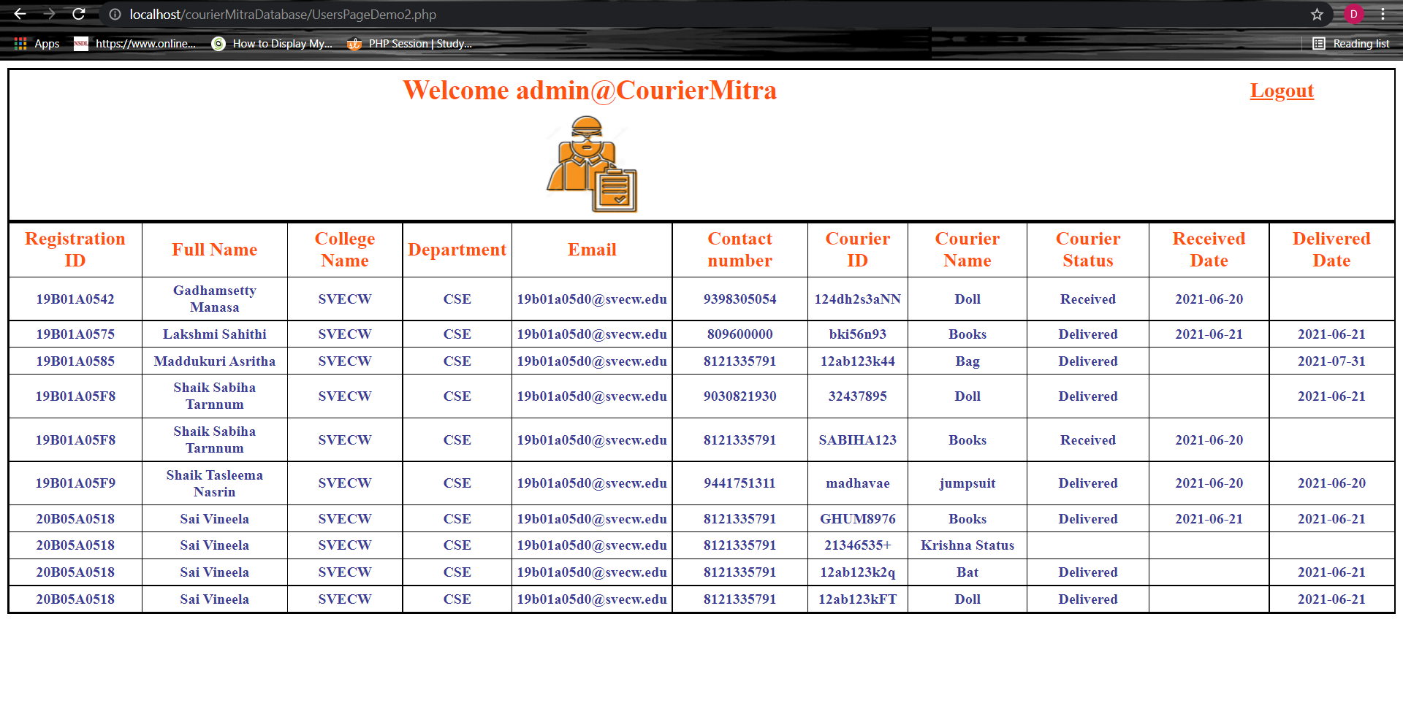

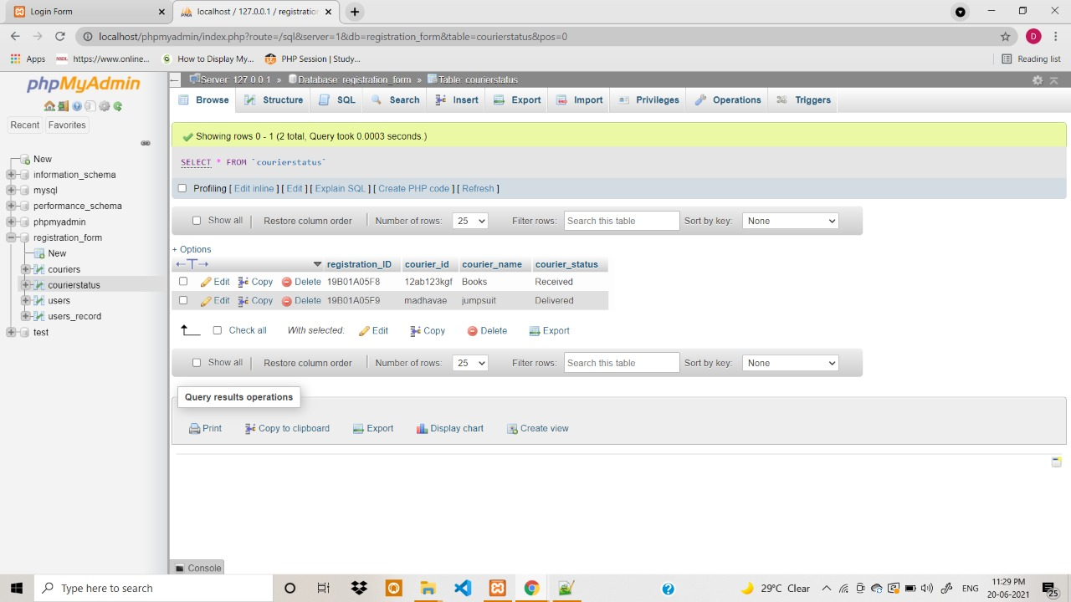

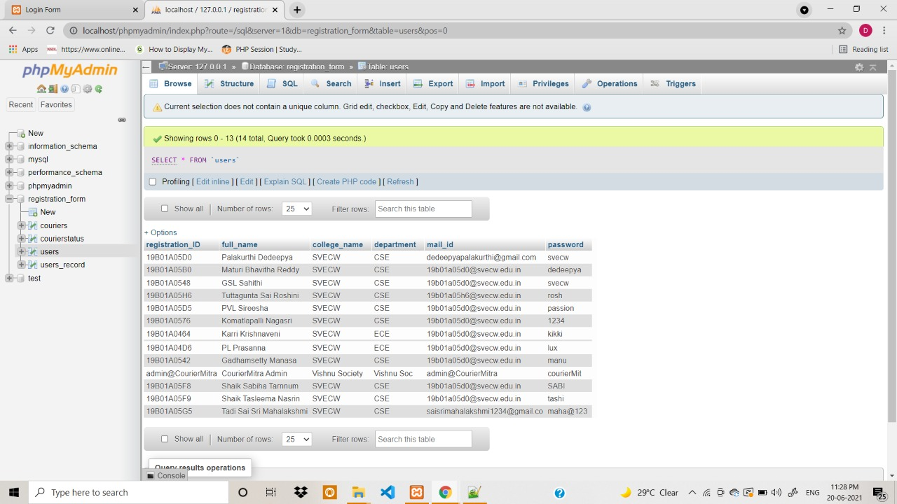

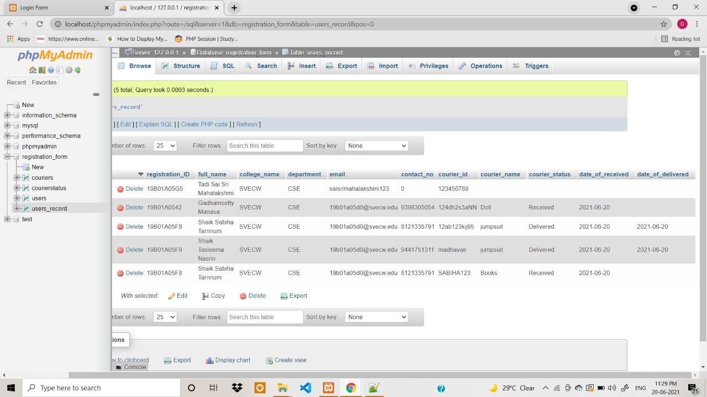

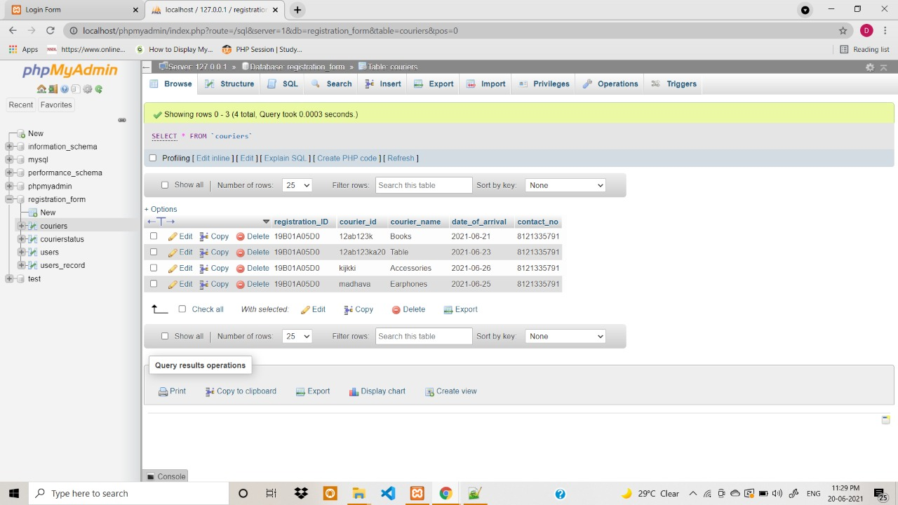

**SYSTEM TESTING**

**6.1 Introduction**

Testing is a set of activities that’s a be planned in advanced band conduct systematically. A strategy testing must accommodation low-level testing that are necessary to verify that is mall source code segment has been correctly implemented as well as high-level that validate major system functions against customers requirements. And purpose of testing is to discuss error. Testing is the process trying to discover every conceivable fault or weakness in a work product. It provides away to check the functionally of components, subassemblies, assemblies and or a finished product.

* The good test cases is one that has a high probability of finding a yet undiscovered error.
* A good test is not redundant.
* A good test should be neither too simple too complicated.

**6.2 Testing Methods**

The following are different testing methodologies.

1. Black box testing.
2. White box testing.
3. Unit testing.
4. Integrated testing.
5. Validation testing.

**Black Box Testing:**

An black box approach to testing is to devise sample data that is representative of all possible data. We then run the program , input the data and see what happens. This type of testing is termed black box testing, because no knowledge of the working of the program is used as part of testing. We only consider inputs and outputs.

The black box testing enables the software engineer to find error in the following categories.

* Incorrect or missing functions.
* Interface error.
* Errors in data structures or external database access.
* Performance errors.
* Initialization errors.

**White Box Testing:**

White box testing makes use of knowledge of how the program works the structure of the program as the basic for devising test data. In white box testing every statement in the program is executed at some time during the testing. This equivalent to ensuring the every path ( every sequence of instruction) through the program is executed at some time during testing. This testing help the software engineer in the following directions.

* Guarantee that all the independent paths within the module have been exercised at least once.
* Exercise all logical decisions on their true and false sides.
* Execute all loops at their boundaries and within their validity.
* Exercise internal data structure to ensure their validity.

**Unit Testing :**

Unit testing focuses verification effort on the smallest unit of the software design the software component or module. An unit testing always white box oriented. Using the component level design description as a guide, important control path are tested to uncover error within the boundary of the modules. Therefore, unit testing tests each component in isolation the goal of this testing level is too see if the modules have been integrated properly. In other words, the emphasis is an testing the Interaction among the module. This testing activity can be considered as testing the design. The tests that occur as part of unit testing are testing the module interface examining the local data structure, testing the boundary conditions, execution all the independent paths and testing error handling paths.

**Integrated Testing :**

The goal of this testing level is to see if the modules have been be integrated properly. In other words, the emphasis is on testing the interaction among the modules. This testing activity can be considered as testing the design. There have two type of different incremental integration strategies are given below.

1. Top – down integration.
2. Bottom – up integration.

**Top – Bottom Integration:**

Top – down integration testing is an integration testing technique used in order to simulate the behaviour of the lower – level modules that are not yet integrated stubs are the modules that act as temporary replacement for the module and give the same output as that of the actual product the top – down integration testing is a method in which integration testing takes place from top to bottom following control flow of the software system. The higher level modules are tested and integrated in order to check the software functionality.

**Advantages:**

1. Family localization is easier.
2. Possibility to obtain an early prototype.
3. Critical module are tested on priority; major design flames could be found and first.

**Disadvantages:**

1. Needs may stubs.

2. Modules at a lower level a tested in adequately.

**Bottom – Up Integration:**

Bottom – up integration testing is a strategy in which the Lower level modules are tested first. These tested modules are then further used to facilitates the testing of higher level modules. The process continues until all modules are tested and integrated. Then the next level of module is forms.

**Advantages**:

1. Fault localization is easier.
2. No time is wasted waiting for all modules to be developed unlike Big – Bang approach.

**Disadvantages:**

1. Critical modules at the top level of the software architecture which control the flow of application are tested last and may be prone to defeats.
2. An early prototype is not possible.

**Validation Testing:**

An validation testing refers to different set of activities that ensures. that the software that has been built is traceable to the customer requirement validation is the check that “ the product made is what was required”. The process of evaluation software during the development process or at the end of the development process to determine whether it satisfies specified business requirements. Validation testing ensure that the product actually meets the client needs.

**Importance of Validation Testing:**

1. To ensure customer satisfaction.
2. To be confident about the product.
3. To fulfil the client requirements until the optimum capacity.
4. Software acceptance from the end user.

**Other Testing Methodologies:**

**1. User acceptance testing:**

User Acceptance of a system is the key factor for the success of any system. The system under consideration is tested for user acceptance by constantly keeping in touch with the prospective system users at the time of developing and making changes wherever required. The system developed provides a friendly user interface that can easily be understood even by a person who is new to the system.

**2.Output Testing:**

After performing the validation testing, the next step is output testing of the proposed system, since no system could be useful if it does not produce the required output in the specified format. Asking the users about the format required by them tests the outputs generated or displayed by the system under consideration. Hence the output format is considered in 2 ways – one is on screen and another in printed format.

**Validation Checking:**

Validation checks are performed on the following fields.

**Text Field:**

The text field can contain only the number of characters lesser than or equal to its size. The text fields are alphanumeric in some tables and alphabetic in other tables. Incorrect entry always flashes and error message.

**Numeric Field:**

The numeric field can contain only numbers from 0 to 9. An entry of any character flashes an error messages.

The individual modules are checked for accuracy and what it has to perform. Each module is subjected to test run along with sample data. The individually tested modules are integrated into a single system. Testing involves executing the real data information is used in the program the existence of any program defect is inferred from the output. The testing should be planned so that all the requirements are individually tested. A successful test is one that gives out the defects for the inappropriate data and produces and output revealing the errors in the system.

### **Preparation of Test Data**

Taking various kinds of test data does the above testing. Preparation of test data plays a vital role in the system testing. After preparing the test data the system under study is tested using that test data. While testing the system by using test data errors are again uncovered and corrected by using above testing steps and corrections are also noted for future use.

**Using Live Test Data:**

Live test data are those that are actually extracted from organization files. After a system is partially constructed, programmers or analysts often ask users to key in a set of data from their normal activities. Then, the systems person uses this data as a way to partially test the system. In other instances, programmers or analysts extract a set of live data from the files and have them entered themselves.

It is difficult to obtain live data in sufficient amounts to conduct extensive testing. And, although it is realistic data that will show how the system will perform for the typical processing requirement, assuming that the live data entered are in fact typical, such data generally will not test all combinations or formats that can enter the system. This bias toward typical values then does not provide a true systems test and in fact ignores the cases most likely to cause system failure.

**Using Artificial Test Data:**

Artificial test data are created solely for test purposes, since they can be generated to test all combinations of formats and values. In other words, the artificial data, which can quickly be prepared by a data generating utility program in the information systems department, make possible the testing of all login and control paths through the program. The most effective test programs use artificial test data generated by persons other than those who wrote the programs. Often, an independent team of testers formulates a testing plan, using the systems specifications. The package “Virtual Private Network” has satisfied all the requirements specified as per software requirement specification and was accepted.

### **User Training:**

Whenever a new system is developed, user training is required to educate them about the working of the system so that it can be put to efficient use by those for whom the system has been primarily designed. For this purpose the normal working of the project was demonstrated to the prospective users. Its working is easily understandable and since the expected users are people who have good knowledge of computers, the use of this system is very easy.

**MAINTAINENCE**

This covers a wide range of activities including correcting code and design .,n errors. To reduce the need for maintenance in the long run, we have more accurately defined the user’s requirements during the process of system development. Depending on therequirements, this system has been developed to satisfy the needs to the largest possible extent. With development in technology, it may be possible to add many more features based on the requirements in future. The coding and designing is simple and easy to understand which will make maintenance easier.

**6**.**3 Test cases:**

|  |  |  |  |  |  |
| --- | --- | --- | --- | --- | --- |
| **Test Case Number** | **Test Case Description** | **Test Data** | **Expected Result** | **Actual Result** | **Pass/Fail** |
| 1. | Check whether message is popped up without filling password field in Login page. | Click on Login button without filling credentials | Message should be popped up saying Fill out this field | Message : Fill out this field is popped up | Pass |
| 2. | Check response if valid email-id and password are entered | Email : 19b01a05d0@svecw.edu.in  Password:  svecw | Login should be successful | Login was successful | Pass |
| 3. | Check response if either of email-id or password are not valid | Email:  [abcx23870@gmail.com](mailto:abcx23870@gmail.com)  Password:  123567 | Message should be popped up saying that Invalid credentials | Invalid credentials  Alert message popped up | Pass |
| 4. | Check if existing user can register again | Registration ID :  19B01A05D0 | Message saying User already exists. Try another user_id should be popped up | Message saying User already exists. Try another user_id popped up | Pass |
| 5. | Check whether email is sent to user after successful registration, filling courier details | 1. Register with all the required details.  2. Fill the courier details once after login. | Email regarding successful registration, details of courier and status of courier should be sent | Email is sent to the user accordingly | Pass |
| 6. | Check whether admin can view all the users courier details | Admin login  Email :  admin@CourierMitra  Password :  couriermit | Courier details of users whose couriers are not delivered yet should be displayed | Courier details of users whose couriers are not delivered are displayed | Pass |
| 7. | Check whether the user is been disappeared from the page when admin clicks on delivered button | Admin clicks on delivered button | Corresponding user should get disappeared from the list of users | Corresponding user is disappeared once the admin clicked delivered button | Pass |
| 8. | Check whether user can get confirmation to mail of courier status | Courier status has to be updated by admin.. | Email should be sent to the user if the courier is received or delivered by admin | Email sent to user succesfully | Pass |
| 9. | Check whether new password works fine if user changes or clicks on forget password | User clicks on change/ forget password and set new password | Message saying Your new password new_password is set should be popped up | Your new password new_password is set message is popped up | Pass |
| 10. | Check whether admin can view all the users records | Click on Users record available on top right corner of admin page | A table with entire details of users should be displayed | All the personal and courier information of all the users of CourierMitra is displayed | Pass |
| 11. | Check if user can Logout properly | Click Logout button | Logged-out and returned to home(Login)page | Successfully logged-out and returned to home page | Pass |

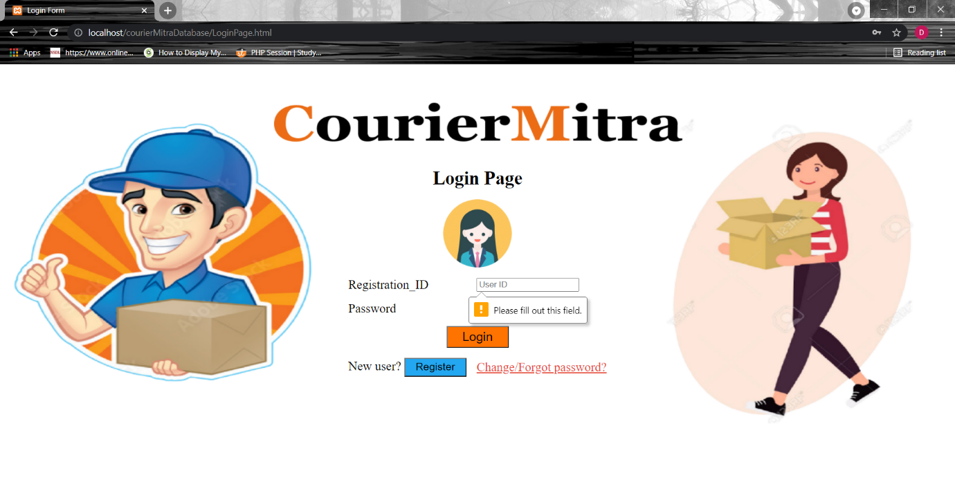**1.**

**2.**

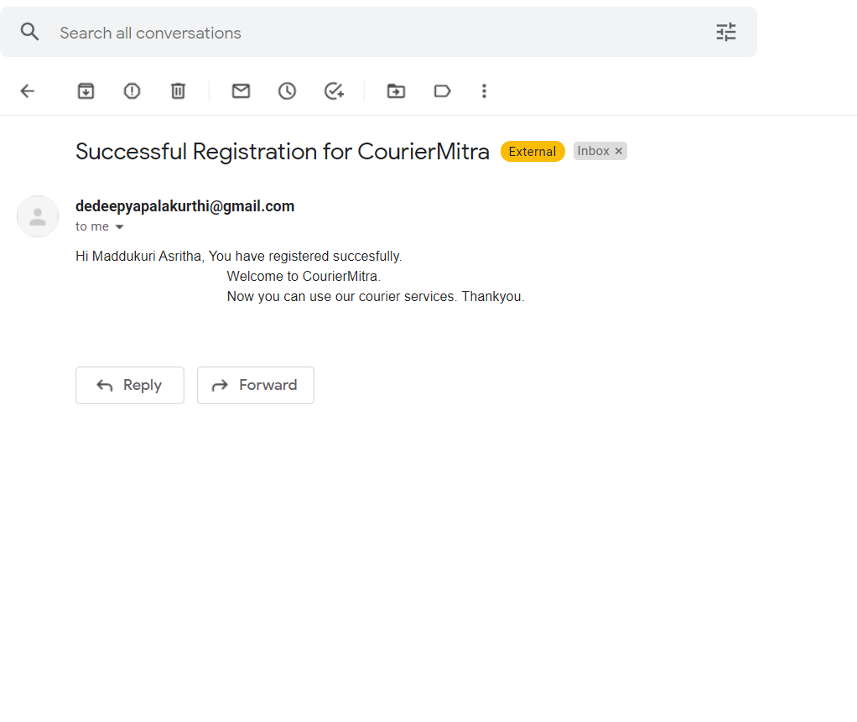

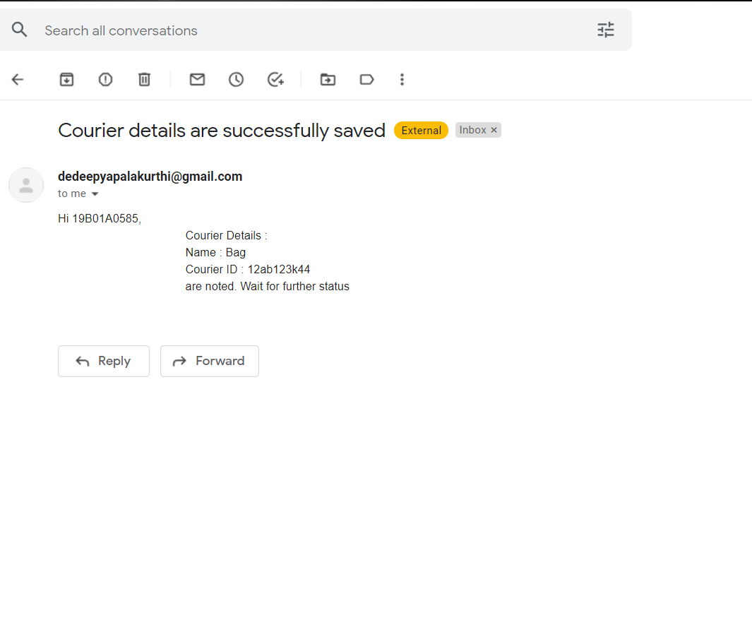**3.**

**4.**

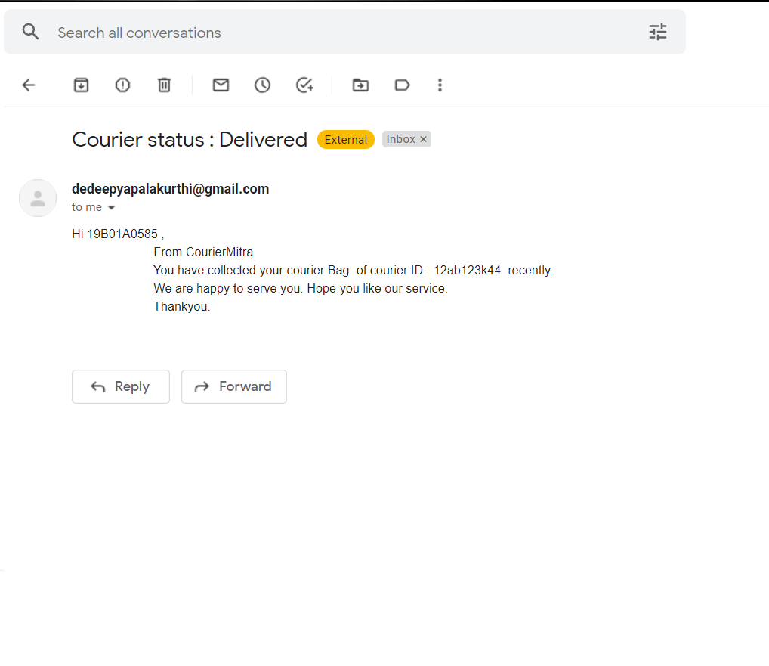

**7. Conclusion & Future Enhancements:**

The courier service system project provides user interface in to the application through an anesthetized admin. The entire project has been developed and developed as per the requirements stated by the user, it is found to be bug free as per the testing standard that is implemented. Any specific- untraced errors will be concentrated in the coming version , which are planned to be developed in near future. The system at present does not take care of the money payment methods, as the consolidated constructs need SSL standard and are critically toe initiated in the first face, the application of the credit card transactions is applied as a developmental phase in the coming days. The system needs more elaborate technicality for its inception and evaluation and also it’s a modern way of usage to a courier service through a computer system. The main proposed system of this wed application via to remove the item details and check the current status of the user. In courier service sector major company is providing services but in India flight courier is leading company in courier sector. Courier facility in India is very cheaper and minimum charges we can send courier from on destination to another.

Various reports of the couriers which are received and delivered to the user will be retrieved in a single page in admin portal.

1. To get the count and details of users couriers :

* College wise
* Department wise
* Monthly report
* Annual report
* Online Platform

1. Sending SMS to users mobile.
2. **Bibliography :**

<https://w3schools.com/>

<https://youtu.be/ueWpNe0PG34>

[https://youtube.com/playlist? list=PLejKBGxF74J6Vm4RB06-3Qzxz1dn5XROR/](https://youtube.com/playlist?%20list=PLejKBGxF74J6Vm4RB06-3Qzxz1dn5XROR/)

Text books :

1. Raghurama Krishnan, Johannes Gehrke, Database Management Systems, 3 rd Edition,

TATA McGraw hill.

2. Pankaj Jalote, A Concise Introduction to Software Engineering (Undergraduate Topics in

Computer Science), Springer International Edition.

3. Grady Booch, James Rumbaugh, Ivar Jacobso, The Unified Modeling Language User

Guide, Pearson Education.

**9. APPENDIX :**

**Introduction to HTML :**

HTML stands for Hyper Text Mark-up Language.

HTML is the standard mark-up language for creating Web pages.

HTML describes the structure of web page. It consists a series of elements.

HTML elements tell the browser how to display the content.

**Introduction to CSS :**

CSS stands for Cascading Style Sheets. CSS describes how HTML elements are to be displayed on screen, paper or in other media. CSS saves a lot of work. It can control the layout of multiple pages all at once. External style sheets are stored in CSS files. It is the language for describing the presentation of Web pages, including colours, layout and fonts thus making our web pages presentable to the users.

**Introduction to JavaScript :**

JavaScript is a lightweight, cross-platform, and interpreted scripting language .It is well-known for the development of web pages, many non-browser environments also use it. JavaScript can be used for Client- side developments as well as Server-side developments. JavaScript contains a standard library of objects like array, date, and Math and a core set of language elements like operators, control structure and statements.

**Introduction to PHP :**

Php is an acronym for "Hypertext Pre-processor". PHP is a widely -used, open source scripting language. PHP scripts are executed on server. PHP is free to download and use.

**Introduction to MySQL :**

MySQL is a database system used for developing web-based software applications. It is used for both small and large applications. It is a relational database management system (RDBMS). MySQL is fast, reliable and easy to use. MySQL supports standard SQL (Structured Query Language). MySQL was developed by Michael Wide nous.